SQL-E-commerce-Project

- Total sales.
SELECT
ROUND(SUM(sales), 1) AS Total_Sales
FROM
e_data;
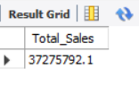

2 - Total Profit.
SELECT
ROUND(SUM(Profit), 1) AS Total_Profit
FROM
e_data;
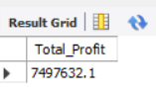
3 - Total Orders.
SELECT DISTINCT
(COUNT(order_id)) AS Total_order
FROM
e_data;
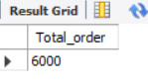
4 - Total customer.
SELECT DISTINCT
(COUNT(Customer_id)) AS Total_Customers
FROM
e_data;
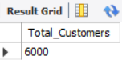
4 - Category-wise Sales.
SELECT
Category, ROUND(SUM(sales), 1) AS Total_sales
FROM
e_data
GROUP BY Category;
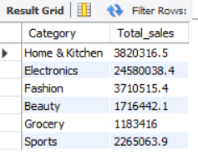
5 - Region-wise Sales.
SELECT
region AS Region, ROUND(SUM(sales), 1) AS Total_sales
FROM
e_data
GROUP BY region;
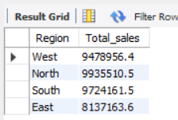

6 - Monthly Sales & Profit.
SELECT
MONTHNAME(order_date) AS Month,
ROUND(SUM(sales), 1) AS Total_sales,
ROUND(SUM(profit), 1) AS Total_profit
FROM
e_data
GROUP BY MONTHNAME(order_date);
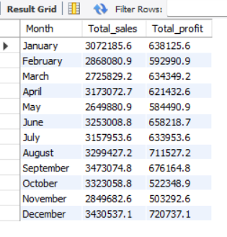
7 - Top 10 Products Sales & Profit.
SELECT
Product_name AS Product,
ROUND(SUM(sales), 1) AS Total_sales,
ROUND(SUM(Profit), 1) AS Total_Profit
FROM
e_data
GROUP BY Product_name
ORDER BY product DESC
LIMIT 10 ;
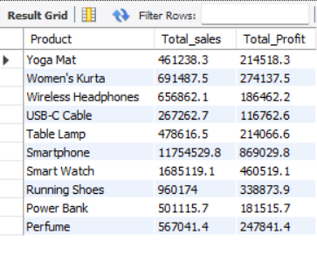

8 - Payment Method Analysis .
SELECT
payment_method AS Payment_method,
count(DISTINCT order_id) AS NO_OF_ORDER
FROM
e_data
GROUP BY Payment_method;
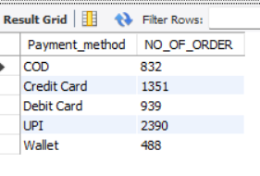
9 - Average Order Value.
SELECT
ROUND(SUM(sales) / COUNT(order_id), 1) AS Avg_Order_Value
FROM
e_data;
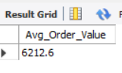

10 - Profit Margin.
SELECT
ROUND(SUM(Profit) / SUM(Sales) * 100, 1) AS Profit_Margin
FROM
E_data;
